**Muhammad Umar Ahmadzai**

**02/10/2018**

**Tax Machine**

**Problem Statement:**

The program is going to ask the user for tax filling type, and then will ask the user again for the income. According to user’s filling status and income the tax will be calculated by the program and will be shown to the user.

**Input/Output Description:**

**Following are going to output types of filling:**

cout << "Please select one of options for filling status." << endl <<endl;

cout << "1. For single filing, press 1."<< endl;

cout << "2. For married filling or qualifying widow/widower, press 2." << endl;

cout << "3. For married filling separately, press 3." << endl;

cout << "4. For head of household filing, press 4." <<endl << endl;

**Following will use if else statement to categorize and calculate the taxes:**

if (fillingstatus==1)

{

**Asking user for income:**

cout << "Please enter your income: " << endl <<endl;

**Inputting Income:**

cin >> income;

**It will keep continug for all of other filling categories.**

**Algorithm Development:**

Basically, we are creating a total of three variables. Filling status will input the filling status from the user, and income will input the amount of income from the user. Taxforincome will calculate the amount of tax the user is supposed to pay. There are four types of tax filing, user is going to choose, and the program is going to run it according by if and else statement. It will redirect the user to correct statement and will calculate taxes for the user.

**Program Listing:**

#include <iostream>

using namespace std;

int main()

{

int fillingstatus, income, taxforincome;

cout << "Please select one of options for filling status." << endl <<endl;

cout << "1. For single filing, press 1."<< endl;

cout << "2. For married filling or qualifying widow/widower, press 2." << endl;

cout << "3. For married filling separately, press 3." << endl;

cout << "4. For head of household filing, press 4." <<endl << endl;

cin >> fillingstatus;

if (fillingstatus==1)

{

cout << "Please enter your income: " << endl <<endl;

cin >> income;

if (income <= 6000)

{

taxforincome=(income*10)/100;

cout << "You will be taxed: " << taxforincome << "$." << endl;

}

else if (income > 6000 and income <=27950)

{

taxforincome=(income-6000)*.15 + (6000*0.10) ;

cout << "You will be taxed: " << taxforincome << "$." << endl;

}

else if (income > 27950 and income<=67700)

{

taxforincome=(income-27950)*.27 +(27950-6000)*.15 + (6000 *0.10);

cout << "You will be taxed: " << taxforincome << "$." << endl;

}

else if (income > 67700 and income<=141250)

{

taxforincome=((income-67700)*0.30)+ ((67701 - 27950) *0.27) +(27950-6000)*.15 + (6000*0.10);

cout << "You will be taxed: " << taxforincome << "$." << endl;

}

else if (income > 141250 and income<=307050)

{

taxforincome=((income-141250)*0.35)+ (141250 - 67700) * 0.30 + ((67701 - 27950) * 0.27) +(27950-6000)*.15 + (6000*0.10);

cout << "You will be taxed: " << taxforincome << "$." << endl;

}

else if (income > 307050)

{

taxforincome=(income*38.6)/100;

cout << "You will be taxed: " << taxforincome << "$." << endl;

}

else

{

cout <<"Next Option." << endl;

}

}

//______________________________________________________________________

if (fillingstatus==2)

{

cout << "Please enter your income: " << endl <<endl;

cin >> income;

if (income <= 12000)

{

taxforincome=(income*10)/100;

cout << "You will be taxed: " << taxforincome << "$." << endl;

}

else if (income > 12000 and income <=46700)

{

taxforincome=(income-12000)*.15 + (12000*0.10) ;

cout << "You will be taxed: " << taxforincome << "$." << endl;

}

else if (income > 46700 and income<=112850)

{

taxforincome=(income-46700)*.27 +(46700-12000)*.15 + (12000 *0.10);

cout << "You will be taxed: " << taxforincome << "$." << endl;

}

else if (income > 112850 and income<=171950)

{

taxforincome=((income-112850)*0.30)+ ((112850 - 46700) *0.27) +(46700-12000)*.15 + (12000 *0.10);

cout << "You will be taxed: " << taxforincome << "$." << endl;

}

else if (income > 171950 and income<=307050)

{

taxforincome=((income-171950)*0.35)+ (171950 - 112850) * 0.30 + ((112850 - 46700) * 0.27) +(46700-12000)*.15 + (12000*0.10);

cout << "You will be taxed: " << taxforincome << "$." << endl;

}

else if (income >307050)

{

taxforincome=(income*38.6)/100;

cout << "You will be taxed: " << taxforincome << "$." << endl;

}

else

{

cout <<"Next Option." << endl;

}

}

//______________________________________________________________________

if (fillingstatus==3)

{

cout << "Please enter your income: " << endl <<endl;

cin >> income;

if (income <= 6000)

{

taxforincome=(income*10)/100;

cout << "You will be taxed: " << taxforincome << "$." << endl;

}

else if (income > 6000 and income <=23350)

{

taxforincome=(income-6000)*.15 + (6000*0.10) ;

cout << "You will be taxed: " << taxforincome << "$." << endl;

}

else if (income > 23350 and income <= 56425)

{

taxforincome=(income-23350)*.27 +(23350-6000)*.15 + (6000 *0.10);

cout << "You will be taxed: " << taxforincome << "$." << endl;

}

else if (income > 56425 and income<=85975)

{

taxforincome=((income-56425)*0.30)+ ((56425 - 23350) *0.27) +(23350-6000)*.15 + (6000*0.10);

cout << "You will be taxed: " << taxforincome << "$." << endl;

}

else if (income > 85975 and income<=153525)

{

taxforincome=((income-85975)*0.35)+ (85975 - 56425) * 0.30 + ((56425 - 23350) * 0.27) +(23350-6000)*.15 + (6000*0.10);

cout << "You will be taxed: " << taxforincome << "$." << endl;

}

else if (income >=153525)

{

taxforincome=(income*38.6)/100;

cout << "You will be taxed: " << taxforincome << "$." << endl;

}

else

{

cout <<"Next Option." << endl;

}

}

//______________________________________________________________________

if (fillingstatus==4)

{

cout << "Please enter your income: " << endl <<endl;

cin >> income;

if (income <= 10000)

{

taxforincome=(income*10)/100;

cout << "You will be taxed: " << taxforincome << "$." << endl;

}

else if (income > 10000 and income <=37450)

{

taxforincome=(income-10000)*.15 + (10000*0.10) ;

cout << "You will be taxed: " << taxforincome << "$." << endl;

}

else if (income > 37450 and income<=96700)

{

taxforincome=(income-37450)*.27 +(37450-10000)*.15 + (10000 *0.10);

cout << "You will be taxed: " << taxforincome << "$." << endl;

}

else if (income > 96700 and income<=156600)

{

taxforincome=((income-96700)*0.30)+ ((96700 - 37450) *0.27) +(37450-10000)*.15 + (10000 *0.10);

cout << "You will be taxed: " << taxforincome << "$." << endl;

}

else if (income > 156600 and income<=307050)

{

taxforincome=((income-156600)*0.35)+ (156600 - 96700) * 0.30 + ((96700 - 37450) * 0.27) +(37450-10000)*.15 + (10000*0.10);

cout << "You will be taxed: " << taxforincome << "$." << endl;

}

else if (income >307050)

{

taxforincome=(income*38.6)/100;

cout << "You will be taxed: " << taxforincome << "$." << endl;

}

else

{

cout <<"Next Option." << endl;

}

}

}

**Sample test run of the program:**

Please enter the filing status.

After choosing 1, please input the income (150000).

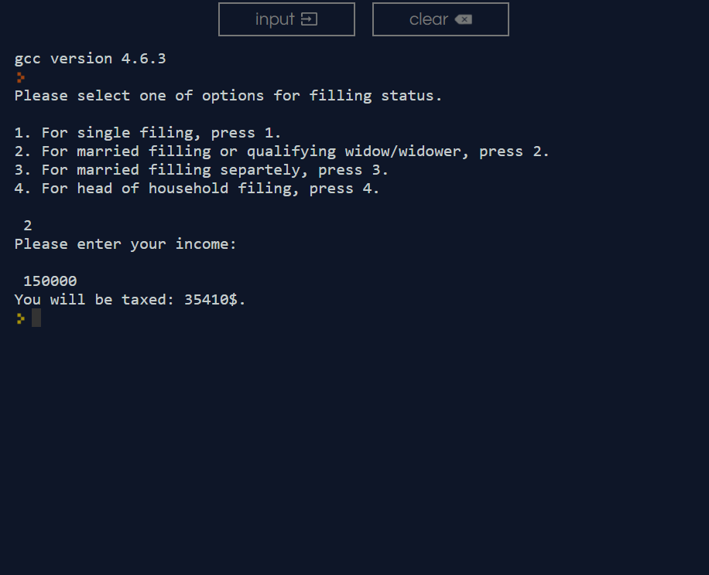Tax result will be outputted.

**Observation and Error Handling and general comments:**

Did not faced any errors.

**Conclusion:**

In conclusion, user is required to enter the filling status and the income. The program is going to generate the taxes and output the amount user is supposed to pay.